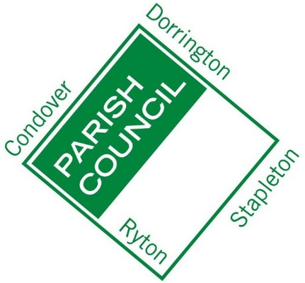
Condover Parish Council’s Latest Initiative:
Condover Parish Council’s Annual Parish Community Recognition Scheme 2016

Community recognition are to recognise those individuals that have made and are making a positive contribution to Condover Parish life and are showing leadership, initiative or commitment in their local community.

Which of the category of recognition is your nomination for:

..........................................................................................................

Example Categories:
• Young Person of the Year
• Good Neighbour
• Exemplary Achievement Award

About you
Your name: ……………………………………………………………………………………
Your address: ...............................................................................................................
………………………………………………………………………………………………….
Your telephone number and email address if you have one:
.......................................................................................................................................
About your nomination
Which person are you nominating?
Name of person: .........................................................................................................
Contact details for this person or team: ………………………………………………….
…………………………………………………………………………………………………
…………………………………………………………………………………………………

Your reasons for nominating this person for this award
Please provide as much information as possible on how the person you have nominated has contributed to the community in the category chosen by you.
Photographs illustrating activities may also be attached. You can refer to achievements, projects, a difference that has been made, engagement with neighbours & residents, the skills and experience of the person, challenges met or initiatives taken.
…………………………………………………………………………………………………
…………………………………………………………………………………………….…..
…………………………………………………………………………………………………
…………………………………………………………………………………………………
…………………………………………………………………………………………………
…………………………………………………………………………………………………
…………………………………………………………………………………………………
…………………………………………………………………………………………………
…………………………………………………………………………………………………
…………………………………………………………………………………………………
…………………………………………………………………………………………………
…………………………………………………………………………………………………
…………………………………………………………………………………………………
…………………………………………………………………………………………………
…………………………………………………………………………………………………
…………………………………………………………………………………………………
…………………………………………………………………………………………………
…………………………………………………………………………………………………

Please continue on additional sheets if you wish.

Please return this nomination form to the Parish Clerk Sue Hackett, Gonsal House,
Condover SY5 7EX or by email to condoverpc@btinternet.com
To be received by the Clerk by the end of March 2016.

