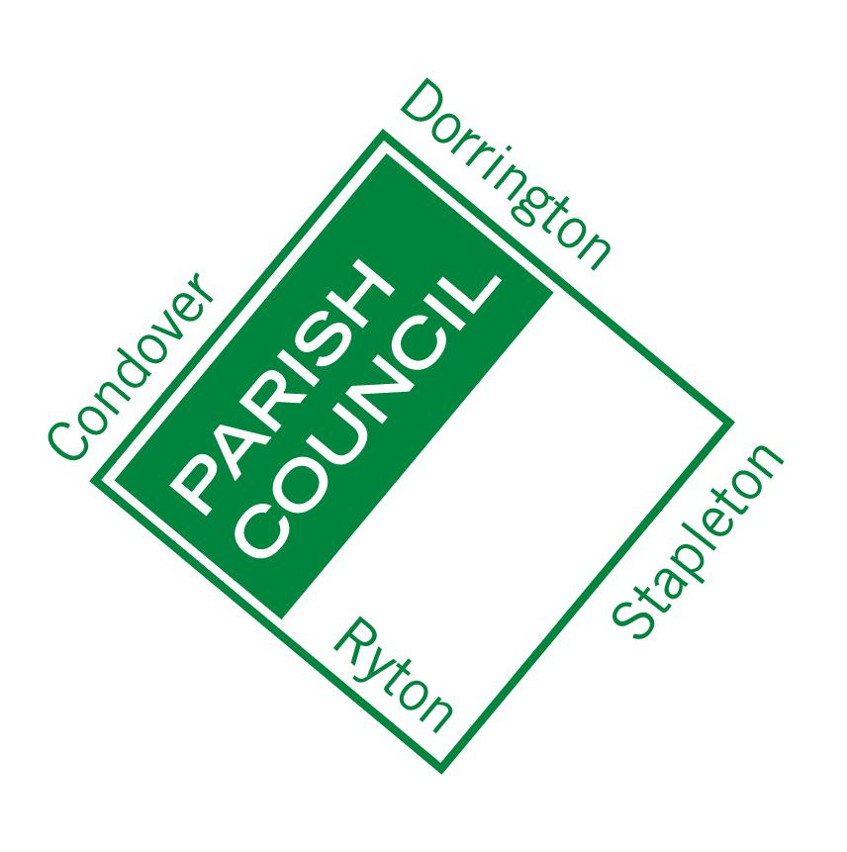
Condover Parish Council
“working in partnership to make our Parish a better place to live in”

CONSENT FORM: DATA PROTECTION
Your privacy is important to us, and we want to communicate with people in a way which has their consent, and which is in line with UK law on data protection. As a result of a change in UK law, we now need your consent to how we contact you. Please fill in the contact details you want us to use to communicate with you:
Name
Address
Business (where applicable)
Email address
Phone Number
Mobile Phone

By signing this form you are confirming that you are consenting to Condover Parish Council holding and processing your personal data for the following purposes (please tick the boxes where you grant consent):-
I consent to Condover Parish Council contacting me by post phone or email.
☐ To keep me informed about news, events and activities connected to Condover Parish Council (note you can unsubscribe at any time);
☐ To share my contact details with professional and other agencies, groups or individual as and only as required and agreed in order to enable you to receive assistance, advice and information and/or to assist with the resolution of your query, and/or enable you to deliver services to the Parish Council:

Signed: Dated:
You can grant consent to all the purposes; one of the purposes or none of the purposes. Where you do not grant consent we will not be able to use your personal data; (so for example we may not be able to let you know about forthcoming events or matters affecting Parish life); except in certain limited situations, such as where required to do so by law or to protect members of the public from serious harm. You can find out more about how we use your data from our “Privacy Notice” which is available at the Parish Council Office or from the Parish Clerk
You can withdraw or change your consent at any time by contacting the Parish Clerk:

Brighid Carey

Dorrington Village Hall Dorrington Shrewsbury, Shropshire, SY5 7LD

email : condoverpc@gmail.com

T: 07516 445872 (Tuesday and Fridays)
Please note that all processing of your personal data will cease once you have withdrawn consent, other than where this is required by law, but this will not affect any personal data that has already been processed prior to this point.

