CONDOVER PARISH NEIGHBOURHOOD PLAN: INITIAL CONSULTATION WITH DORRINGTON BUSINESS NETWORK
1ST MARCH 2019

- Purpose
The purpose of initial consultations with Dorrington Business Network (DBN) was to inform formal consultation with local businesses across the Parish. The aim was to better understand:
- The priorities of businesses working in the Parish
- How to most effectively consult with businesses across the Parish

- Structure
The consultation initial meeting was scheduled to coincide with a monthly DBN breakfast meeting, between 8am – 9am on Friday 1st March 2019.

At the event, the Consultant and Chair of the Condover Parish Neighbourhood Plan Steering Group (CPNPSG) explained the Neighbourhood Plan and the key themes which had emerged from previous community consultations. This included a theme of economic development. There was a display board summarising the purpose of a Neighbourhood Plan, the steps involved in developing one, and the issues identified to date as key concerns for inclusion. There was also a flip chart page asking members of the DBN for ideas about how best to consult with them and what their priorities were, with pens and sticky notes to capture their ideas.

Previous consultations with residents Condover had indicated Condover Parish Neighbourhood Plan should include areas broader than new housing provision, specifically:
- Traffic and transport
- Leisure and amenities
- Facilities
- Economic development
- Heritage and natural environment
Each theme area had an A3 poster and a summary of issues raised at earlier consultations. Businesses were asked to provide their own comments and also say whether anything was missing from their perspective from each theme area.

The consultant also shared feedback from the initial consultations with young people who felt there were missed opportunities for building positive links between local young people and local business, to offer opportunities for work experience, mentoring, training and employment.

- Attendance
Six businesses, including the Shropshire Councillor for Burnell division, attended the meeting and provided thoughts and feedback. There was considerable interest in the notion of offering more opportunities for young people. A summary of feedback is presented in Appendix A

- Learning
With respect to future consultations, the feedback showed that future consultations should be taken out to businesses where they operate, using eg roadshows, pop-up events, leaflet drops and electronic communications. Local press and media should also be considered, especially through any sections targeted towards businesses. Engagement with the Shropshire Council Enterprise Team could lend weight and interest to consultations with local businesses.
Note: Consideration may be given by the Parish Council / within the Neighbourhood Plan to retaining the ‘local £’ in the Parish, especially with respect to eg. grounds maintenance, minor works, office and community services. There is however a potential conflict between local commissioning and the requirement to demonstrate ‘best value’ in these areas which would need to be addressed.

- Recommendations
The following recommendations are made:

- Future consultations with local businesses should be ‘outreach’ based, taking consultations to them, and online
- Contact should be made with Shropshire Council Enterprise Team, for advice and assistance
- Options should be available, with a request to respond just once
- A Condover Parish Neighbourhood Plan group should be set up on Facebook and moderated
- A short questionnaire (max 10 questions) should be devised, for use directly with businesses and as a Facebook/ social media survey
- The draft survey questions in Appendix C should be discussed and a final set agreed with CPNPSG and Condover Parish Council by 9th March 2019
- The survey should be taken out to businesses via a roadshow to the business parks and to a Young Farmers meeting.
- The survey should be carried out before Friday 22nd March 2019

2nd March 2019

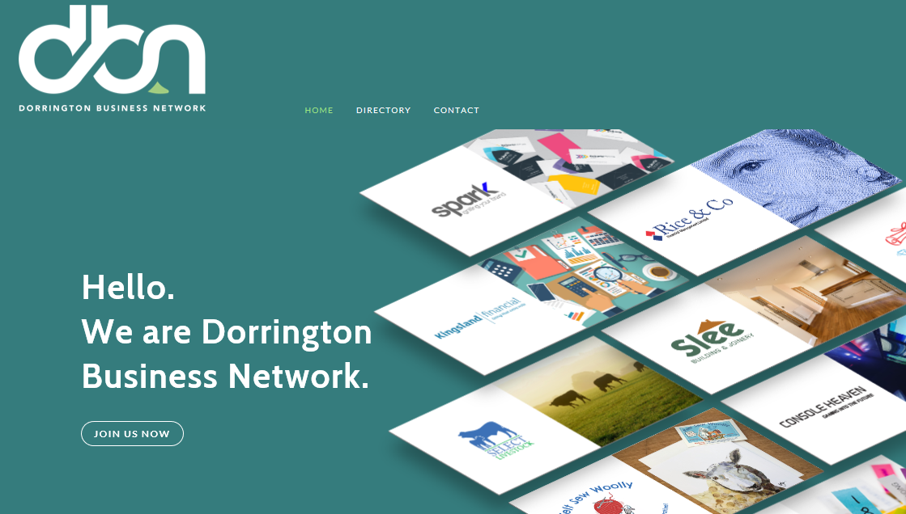

APPENDIX A

SUMMARY OF INITIAL CONSULTATION FEEDBACK FROM DORRINGTON BUSINESS NETWORK

How best to consult with businesses
Get an article in the Shropshire Star – business section
Ask Radio Shropshire to do a feature on CPC Neighbourhood Plan
Ask the Enterprise Team from Shropshire Council to come with the Parish Council and present at a roadshow (engage Shropshire Councillor to assist)
Do a pop-up session in the Horseshoes pub in Dorrington – ask Shropshire Council/Councillor to assist
Go to a Young Farmers rally / meeting and present Neighbourhood Plan
Information / what’s on via Mailchimp
Leaflet drops
Go to business parks and industrial estates in the Parish with business roadshows

Housing
Use local companies when developing new housing schemes – keep investment within the local area

Heritage and Environment
Maintenance of roads and drains

Facilities
No comments

Economic development
Have a jobs page on the DBN and Parish Council websites for businesses in the area to use
Offer ‘taster’ days for school leavers in the area
What about a young person’s apprentice register?
Young people would sign up to a register saying they’re looking for work in the summer for example and then the PC could match them with businesses
Can the Parish Council create a business register and target directly via mail, email, social media
More support required for local companies – council contracts etc

Leisure
No comments

Traffic and Transport
Condover / A49 junction – move 30mph sign to south of this junction

APPENDIX B

DRAFT NEIGHBOURHOOD PLAN SURVEY QUESTIONS – BUSINESSES WITHIN THE PARISH

Introduction to explain the Neighbourhood Plan and Parish area (size)

Q1. Which village are you based in or closest to?

Q2. What is the nature of your business?

Q3. Would you like more opportunity to network with local businesses in the Parish? Yes / No
If yes, would you

- Join a local business network Yes / No
- Participate in a local business directory Yes / No
- Attend occasional events and training sessions Yes / No
- Join in with or sponsor community activities Yes / No
- Download webinars or use business advice pages Yes / No
- Anything else? – please say………….

Q4. How satisfied are you with your broadband speed?

Very satisfied Satisfied Dissatisfied Very Dissatisfied

Comments:

Q5. How easy is it for your business to find and retain the workforce you need?

Very easy Easy Difficult Very difficult Not applicable

Comments:

Q6. Are you planning to expand or diversify your business over the next 2 years? Yes / No
If yes, do anticipate any barriers to expansion / diversification?

Q7. Do you have any comments about traffic and transport in the Parish? Yes / No
If yes, please say here:

Q8. Do you have any other comments about local business and economic development in the Parish?

